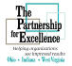

The Partnership for Excellence
829 Bethel Road, #212
Columbus, OH 43214
www.thepartnershipforexcellence.org

2022 Quest for Success - Call for Presentations

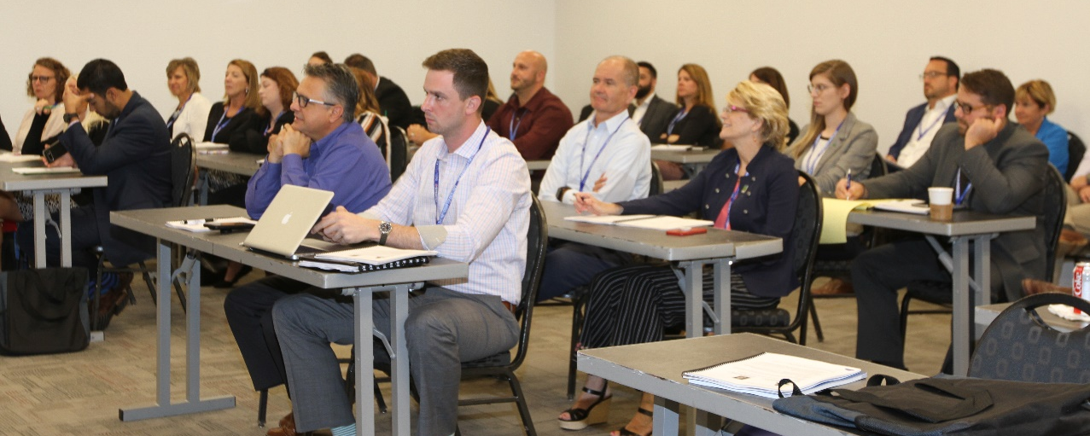

The Partnership for Excellence – 2022 Quest for Success Conference
September 13, 2022 at The Ohio State University, Columbus, Ohio
Celebrating 24 Years of Performance Excellence!

The Partnership for Excellence is seeking qualified speakers to present at our 2022 Quest for Success Conference on September 13, 2022.

Individuals volunteering to speak at the 2022 Quest for Success Conference will submit the following completed Request For Proposal (RFP) for consideration.

Proposals to be submitted to TPE no later than April 30, 2022.

Sessions on the day of presentation are complimentary. Speakers interested in participating in other sessions may register for the conference at www.thepartnershipforexcellence.org. All speakers must register on the conference website when registration opens.

Questions regarding this RFP can be directed to Margot Hoffman, President & CEO at 614-425-7157.

INSTRUCTIONS FOR COMPLETING THE RFP:

1. Complete the Administrative Section of the RFP (see next page)
2. Submission to include:
- Photo(s) and short bio(s) of presenter(s)
- Presentation title and summary of proposed presentation
4. Send the completed RFP (Administrative Section and Submission) to margot.hoffman@partnershipohio.org by April 30, 2022

REQUEST FOR PROPOSAL - ADMINISTRATIVE SECTION

Contact information

Lead Presenter:

Name __________________________________________________________________

Title ______________________________ Organization __________________________

Address_________________________________________________________________

City ____________________________State_______ Zip Code____________________

Phone Number _____________________ E-Mail Address ________________________

Co-Presenter: (if applicable)

Name __________________________________________________________________

Title ______________________________ Organization __________________________

Address_________________________________________________________________

City ____________________________State_______ Zip Code____________________

Phone Number _____________________ E-Mail Address ________________________

Consent to release material information and likeness:

If selected to speak at the 2022 TPE Quest for Success conference, I authorize The Partnership for Excellence to use information provided here and materials submitted in conjunction with this RFP to promote the 2022 conference (check below if you agree to this statement):

_______ Agreed to by Presenter _______ Agreed to by Co-Presenter(s) if applicable

Would you be interested in leading a future TPE webinar? _______ Yes _______ No

Signed ______________________________________________ Date ___________________

